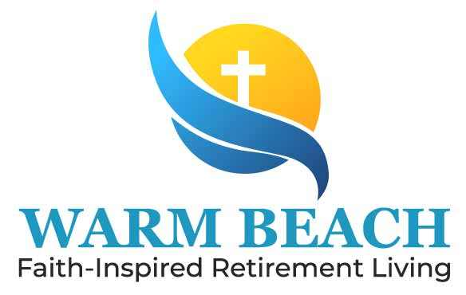

Warm Beach Senior Community
Notice of Privacy Practices


Your Information.
Your Rights.
Our Responsibilities.
This notice describes how medical information about you may be used and disclosed and how you can get access to this information.
Please review it carefully.

When it comes to your health information, you have certain rights.
This section explains your rights and some of our responsibilities to help you.
Ask us to limit what we use or share
• You can ask us not to use or share certain health
information for treatment, payment, or our operations.
• We are not required to agree to your request, and we
may say “no” if it would affect your care.
• If you pay for a service or health care item out-of-pocket in full, you can ask us not to
share that information for payment or our operations with your health
insurer.
• We will say “yes” unless a law requires us to share that information.
Get a list of those with whom we’ve shared information
• You can ask for a list (accounting) of the times we’ve shared your health information for
six years prior to the date you ask, who we shared it with, and why.
• We will include all the disclosures except for those about treatment, payment, and health
care operations, and certain other disclosures (such as any you asked us to make). We’ll
provide one accounting a year for free but will charge a reasonable, cost-based fee if you
ask for another one within 12 months.
File a complaint if • You can complain if you feel we have violated your
you feel your rights by contacting us using the information on the
rights are violated back page.
• You can file a complaint with the U.S. Department of Health and Human Services Office
for Civil Rights by sending a letter to 200 Independence Avenue, S.W., Washington, D.C.
20201, calling 1-877-6966775, or visiting www.hhs.gov/ocr/privacy/hipaa/ complaints/.
• We will not retaliate against you for filling out a complaint

For certain health information, you can tell us your choices about what we share. If you have a clear
preference for how we share your
information in the situations described below, talk to us. Tell us what you want us to do, and we
will follow your instructions.

In the case of fundraising:
• We may contact you for fundraising efforts, but you can tell us not to contact you again.

Our Uses and Disclosures
How do we typically use or share your health information?
We typically use or share your health information in the following ways.

Treat you | • We can use your health information and share it  with other professionals  who are treating you. | Example: A doctor treating you for an injury asks another doctor about your overall health condition.
Run our organization | • We can use and share your health information to run our practice, improve your care, and contact you when necessary. | Example: We use health information about you to manage your treatment and services.
Bill for your services | • We can use and share your health information to bill and get payment from health plans or other entities. | Example: We give information about you to your health insurance plan so it will pay for your services.

Our Use and Disclosures

How else can we use or share your health information?
We are allowed or required to share your information in other ways – usually in ways that contribute to the public good, such as public health and research. We have to meet many conditions in the law before we can share your information for these purposes. For more information see: www.hhs.gov/ocr/privacy/hipaa/understanding/consumers/index.html.
Work with a medical examiner or funeral director | • We can share health information with a coroner, medical examiner, or funeral director when an individual dies.
Address workers’ compensation, law enforcement, and other government requests | - We can use or share health information about you:  - For workers’ compensation claims  - For law enforcement purposes or with a law enforcement official  - With health oversight agencies for activities authorized by law  - For special government functions such as military, national security, and presidential protective services
Respond to lawsuits and legal actions | We can share health information about you in  response to a court or administrative order, or in  response to subpoena.

Help with public health and safety issues
We can share health information about you for certain situations such as:
• Preventing disease
• Helping with product recalls
• Reporting adverse reactions to medications
• Reporting suspected abuse, neglect, or domestic violence
• Preventing or reducing a serious threat to anyone’s health or safety
Do research
• We can use or share your information for health research.
Comply with the law
• We will share information about you if state or federal laws require it, including with the Department of Health and Human Services if it wants to see that we’re complying with federal privacy law.
Respond to organ and tissue donation requests
- We can share health information about you with organ procurement organizations.
organ procurement organizations.

Disclosure of security measures to protect hardware and data
Warm Beach Senior Community (WBSC) utilizes a layered approach to keeping information private and safe. All workstations and servers employ the use of BitLocker drive encryption to limit exposure due to a stolen drive. Servers are kept in a locked room where access is limited. Connections to the internet are protected via commercial grade firewalls with advanced protection enabled.
All workstations and servers are protected using a commercial grade malware software system. The definition files are updated at least daily. Email is provided by Microsoft Office 365 with security measures enabled. WBSC utilized a commercial grade spam engines to help protect the email system. WBSC policy states that all ePHI that is authorized to be transmitted electronically, must be done securely. As such, WBSC uses an encryption service for sending secure emails that contain ePHI.
All workstations and servers automatically lock after a set period of inactivity. This reduces the opportunity for a system to be unintentionally left open for abuse.
Only equipment that has been screened by the Security Office is allowed to connect to WBSC corporate network. Decommissioned hardware is properly recycled including the removal and destruction of any drives.
- We are required by law to maintain the privacy and security of your protected health information.
- We will let you know promptly if a breach occurs that may have compromised the privacy or security of your information.
- We must follow the duties and privacy practices described in this notice and give you a copy of it.
- We will not use or share your information other than as described here unless you tell us we can in writing. If you tell us we can, you may change your mind at any time. Let us know in writing if you change your mind. For more information see: www.hhs.gov/ocr/privacy/hipaa/ understanding/consumers/noticepp.html.

Changes to the Terms of This Notice
We can change the terms of this notice, and the changes will apply to all information we have about you. The new notice will be available upon request, in our office, and on our web site.

This Notice of Privacy Practices applies to the following organizations.
Warm Beach Senior Community. Your information may be shared between our Cedar Court Assisted Living and our Health Care Center. Your information can be used for treatment, operations, and payment.
Warm Beach Senior Community
20420 Marine Drive
Stanwood, WA 98292
Privacy Officer: Mary Ann McIntosh, 360-652-2606
Security Officer: Brian Ferrill, 360-722-7034
August 2026

