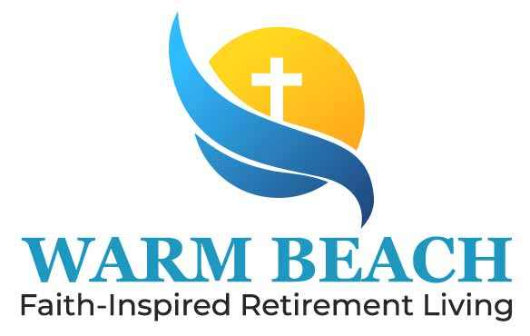

Notice of Privacy Practices
Substance Use Disorder (SUD) Information
Assisted Living / Senior Community Residents
THIS NOTICE DESCRIBES HOW INFORMATION ABOUT YOU MAY BE USED AND DISCLOSED AND HOW YOU CAN ACCESS THIS INFORMATION. PLEASE REVIEW IT CAREFULLY.

Our Commitment to Your Privacy
At Warm Beach Health Care, we respect the dignity, independence, and confidentiality of every resident. Information regarding substance use disorder diagnosis, treatment, or referral is considered highly sensitive and is protected under federal and state privacy laws.
Federal law (42 CFR Part 2) provides additional protections for substance use disorder treatment information beyond standard health privacy laws. We are required to protect this information and only share it under specific circumstances described in this notice.

How We May Use and Disclose Your Information
Treatment and Resident Care
We may use or share your information to provide safe, coordinated care within the assisted living community. This may include communication between:
- Licensed nurses
- Caregivers and medication technicians
- Physicians and nurse practitioners
- Behavioral health providers
- Pharmacy services
- Emergency medical personnel
Information is shared only with staff or providers directly involved in your care and only when permitted by law or with your written consent when required.

Medication Management and Safety
If you receive medication assistance or reminders, limited information may be shared with trained staff responsible for:
- Assisting with medication administration
- Monitoring medication effectiveness
- Observing and reporting side effects or safety concerns
- Coordinating with prescribing providers and pharmacies

Payment and Billing
Your information may be used to obtain payment for services, including billing insurance, Medicaid, private pay services, or other responsible parties when authorized or legally permitted.

Healthcare Operations
We may use your information to support community operations such as:
- Staff training and supervision
- Quality improvement and safety monitoring
- Licensing and regulatory compliance
- Program development and evaluation
All staff are trained to protect resident confidentiality.

Situations Where Disclosure May Occur Without Consent
Federal law allows limited disclosure of SUD information without written consent in specific circumstances, including:
- Medical emergencies when necessary to protect your health or safety
- Court orders that meet federal confidentiality requirements
- Reporting suspected abuse, neglect, or exploitation
- Crimes committed on the premises or against staff or residents
- Approved audits, program evaluations, or research with privacy safeguards

Written Authorization Requirements
Most disclosures involving substance use disorder information require your written authorization. Your authorization must specify:
- What information may be shared
- Who may receive the information
- The purpose of the disclosure
You may withdraw your authorization at any time in writing, except when action has already been taken.

Prohibition on Re-Disclosure
Federal law prohibits individuals or organizations receiving your substance use disorder information from sharing it further unless permitted by law or with your written authorization.

Your Rights as a Resident
You have the right to:
Review and Obtain Copies
You may request access to your health records, subject to certain legal limitations.
Request Corrections
You may request changes if you believe your health information is incorrect or incomplete.
Request Restrictions
You may request limits on how your information is shared or used.
Request Confidential Communication
You may request that staff communicate with you in a specific manner or location.
Request a Disclosure List
You may request a list of certain disclosures of your protected information.
Receive a Copy of This Notice
You may request a paper or electronic copy at any time.

Our Responsibilities
Our assisted living community is required to:
- Maintain the privacy and security of resident information
- Provide this notice explaining our privacy practices
- Follow the terms of this notice
- Notify you if a breach of protected information occurs

Changes to This Notice
We may update this notice as laws or facility practices change. Updated copies will be available to residents and responsible parties upon request.

Questions or Privacy Concerns
If you have questions or believe your privacy rights have been violated, you may contact:
Privacy Officer: Mary Ann McIntosh, 360-652-2606
Community Name: Warm Beach Health Care Center
Address: 20420 Marine DR, Stanwood, WA 98292
Phone: 360-652-7585
You may also file a complaint with the U.S. Department of Health and Human Services. Filing a complaint will not affect your care or residency.

Resident Acknowledgment
I acknowledge that I have received and reviewed this Notice of Privacy Practices regarding Substance Use Disorder confidentiality protections.
Resident Name: __________________________
Signature: __________________________
Date: __________________________
Responsible Party/Legal Representative (if applicable): __________________________
Staff Witness: __________________________

